ALGORITHM OF THE PROJECT:

**Step1:** Create a sample text file in Notepad. Follow these steps:

(i)Paste the student details text in Notepad.

(ii)Save the file as p1.txt.

**Step2:** Start Microsoft Visual Studio.

**Step 3: On the File menu, point to New, and then select Project.**

**Step 4:** Select **Visual C# Projects** under **Project Types**, and then select **Console Application** under **Templates**.

**Step 5:** Add the following code at the beginning of the Program.cs file:

**Step 6:** using.System.IO;

**Step 7:** Add the following code to the Main method:

String a;

try

{

StreamReader g = new StreamReader("D:\\p1.txt");

a = g.ReadLine();

while (a != null)

{

Console.WriteLine(a);

a = g.ReadLine();

}

g.Close();

Console.ReadLine();

}

catch (Exception e)

{

Console.WriteLine("Exception: " + e.Message);

}

finally

{

Console.WriteLine("Executing finally block.");

}

**Step 8:** On the **Debug** menu, select **Start** to compile and to run the application. Press ENTER to close the **Console** window. The **Console** window displays the contents of the p1.txt file

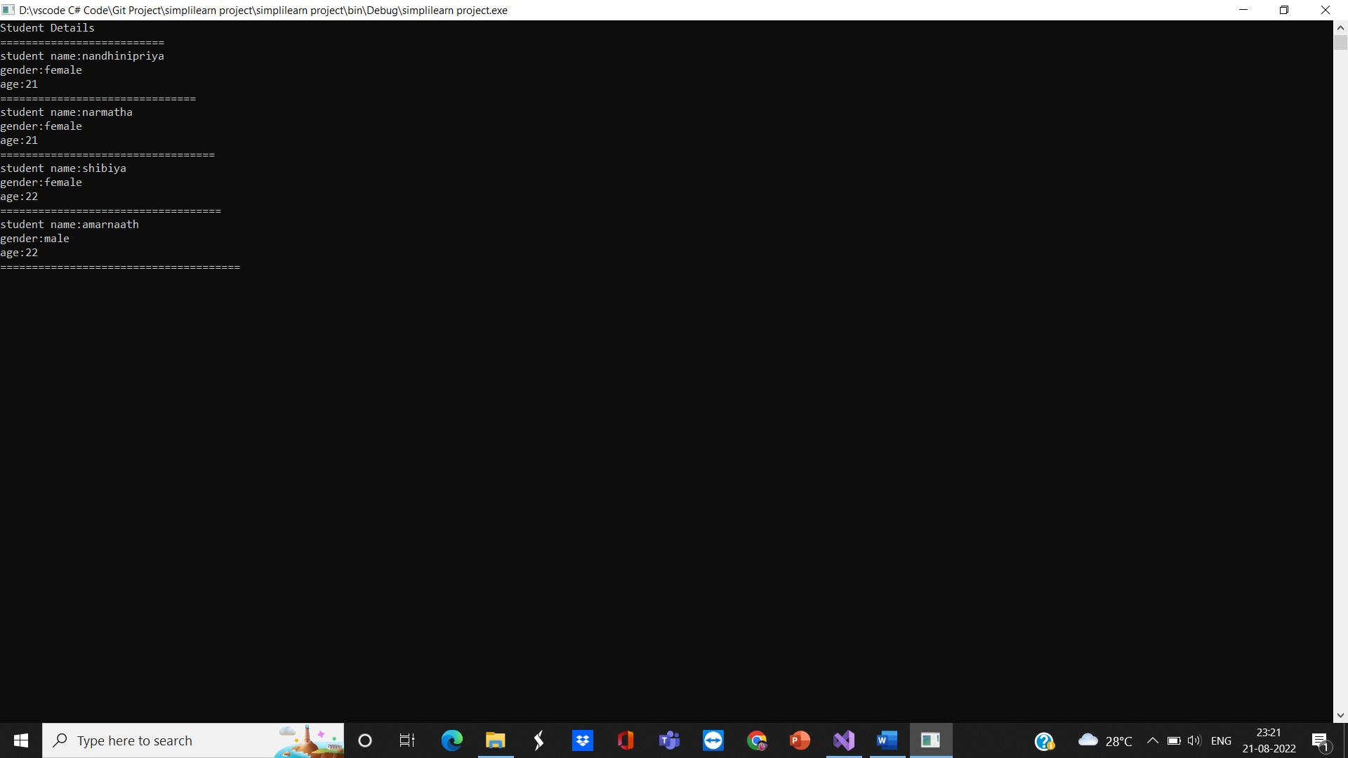

**GITHUB LINK -** [**https://github.com/NandyPriya/Nandhu---.NET.git**](https://github.com/NandyPriya/Nandhu---.NET.git)